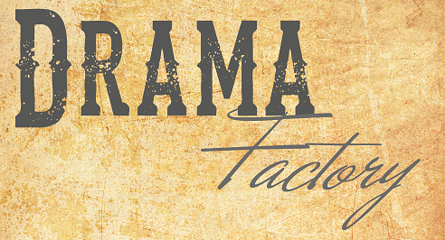
10 Comprop Sq, Henry Vos Close, Asla Business Park, Strand, Cape Town
www.thedramafactory.co.za • 073.215.2290
Brilliant theatre on the boards this weekend with a long overdue play about the complex man that was Beyers Naude'. From an award winning stable we are proud to welcome Helderberg's own star, Ira Blanckenberg to our stage. Ira is joined by Robert Hindley and ably directed by the acclaimed Tara Notcutt - this is not one to miss out on.

Oom Bey, my pa
Drama 65mins
Ira Blanckenberg & Robert Hindley /Regisseur: Tara Notcutt/ Vervaardiger: Leftfoot Productions
Fri 22nd Jul 7:30pm • Sat 23rd Jul 7:30pm • Sun 24th Jul 4pm
Oom Bey, my pa is die jongste toneel uit ATKV- Woordveertjie wenner Henque Heymans se pen. “Ons land is opsoek na ‘n rolmodel, en hierdie is my poging om Oom Bey se naam in die hoed te gooi.” – Henque Heymans, Skrywer Oom Bey, my pa vertel die verhaal van Beyers Naudé soos gesien deur die oë van sy enigste dogter, Liesel Naudé, en fokus op die tyd en oorsake van sy skuif in ideologie – en of dit eintlik ‘n skuif was. Die hoofkarakter Liesel (gespeel deur Ira Blanckenberg) sou tydens haar vormings jare beleef hoe Oom Bey metodies transformeer vanaf die jongste lid van die Broederbond, gebrandmerk word as ‘n “verraaier van die Afrikaner”, tot uiteindelik een van Suid Afrika se belangrikste helde. Robert Hindley speel teenoor Blanckenberg se Liesel ‘n handvol karakters insluitend die lede van Liesel se gesin. Die stuk debuteer by die Suidoosterfees met Tara Notcutt as regisseur.
Tydens ‘n onderhoud by KKNK se jaarlikse Teksmark verduidelik Heymans hoe hy te werke gegaan het met die onderwerp. “Ek’t vir om en by twee jaar lank met die regte Liesel Naudé gesels om haar uitkyk op haar pa se lewe te verstaan. Ek wou die stuk nie polities of teologies maak nie en op hierdie manier kon ek seker wees ons kyk na Oom Bey as mens, eerder as Beyers Naudé die teoloog of vryheidsvegter. Beide van daardie aspekte is vir my meer as gevolg van die tipe mens wie hy was.” Heymans het die teks geskryf tydens ‘n residensie by die Jakes Gerwel Stigting se Paulet huis in Somerset-Oos as deel van die Nati Jong Sterre projek in samewerking met die Suidoosterfees, Artscape en Nati en die speelvak word ook verder ondersteun deur die ATKV en die Beyers Naudé Sentrum.
Oom Bey, my pa het vroeër vanjaar by die Suidoosterfees gedebuteer voor ‘n uitverkoopte gehoor by die Artscape teater sentrum met oorweldigende positiewe terugvoer.
“I highly recommend it” – Dion Forster, voorsitter van die Beyers Naudé Sentrum.
“Die stuk hoort neffens Die Bram Fischer Wals van Harry Kalmer en die onlangse Dance of the La Gumas van Sylvia Vollenhoven en Basil Appollis.” – Leatitia Pople, Netwerk24.
“Uitstekende produksie.” – Gerrie Lemmer, Voorsitter van ATKV.
“Dis emosioneel... Dit laat jou dink, terugdink, vorentoe dink.” Marguerite Van Wyk, resensent. Photo Credits: KKNK Teksmark 2021 | Nardus Engelbrecht

